**Nov 2014 HL P1**

**Section A**

1. State **one** example of application software. [1]

*Award* ***[1 mark]*** *for a valid example.*

Word processor; spreadsheet; database management system; e-mail; web browser; CAD; graphic processing software;

1. Identify **two** methods that can be used to prevent data loss. [2]

*Award* ***[1 mark]*** *for each method identified up to* ***[2 marks max]****.*

Failover systems;

Redundancy;

Removable media;

Offsite / online storage;

1. Identify **two** methods of providing user documentation. [2]

*Award* ***[1 mark]*** *for each method identified up to* ***[2 marks max]****.*

Help files;

Online support;

Printed manuals;

1. Outline the need for higher level languages. [2]

*Award* ***[1 mark]*** *for identifying one need for a higher level language and* ***[1 mark]*** *for further development of that idea or the identification of a second need up to* ***[2 marks max]****.*

In machine language, the basic operations available are too simple;

The operations used in modern programming are far more abstract than the basic operations of the computer;

It would take too long to complete systems in machine code;

1. State **one** function of the operating system in managing memory. [1]

*Award* ***[1 mark]*** *for a function stated.*

Allocating storage for data and instructions;

Keeping track of free and occupied parts of memory;

1. Construct a logic diagram for the Boolean expression

A and B or not B. [3]

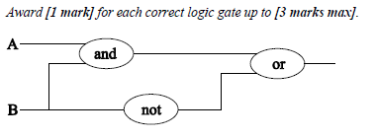

1. Define the term recursion. [1]

*Award* ***[1 mark]*** *for a definition that covers the basis of the term.*

Process that calls itself;

1. 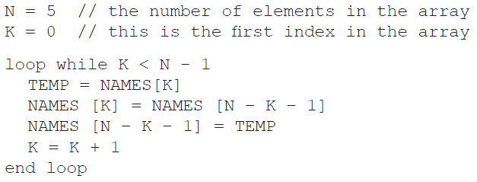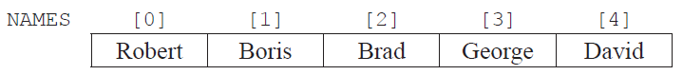Consider the following array  
     
     
     
     
   and the following algorithm, which is constructed to reverse the contents of the array NAMES.
2. Trace the algorithm, showing the contents of the array after each execution of the loop. [2]

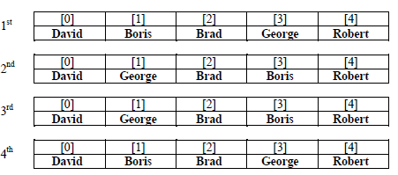

1. Identify the type of error that occurs. [1]

Logic error;

1. Outline why the error occurs and how it could be corrected. [2]

*Award* ***[1 mark]*** *for stating a possible cause of error.*

Loop executes too many times;

Terminating value for controlling variable was not correctly set;

*Award* ***[1 mark]*** *for stating a possible solution.*

Condition should be changed to k = n div 2;

1. (a) Outline the differences between a LAN and a VLAN. [3]

*Award* ***[1 mark]*** *for identifying one difference between a LAN and a VLAN and* ***[1 mark]*** *for further development of that idea or identifying another difference up to* ***[3 marks max]****.*

A LAN is a physical, local area network defined by cables, and networking hardware whereas;

A VLAN is a virtual LAN defined by software parameters programmed into the networking hardware;

(b) Identify **two** factors that should be considered when selecting transmission media. [2]

*Award* ***[1 mark]*** *for each factor identified up to* ***[2 marks max]****.*

Cost;

Speed;

Security;

Reliability;

1. 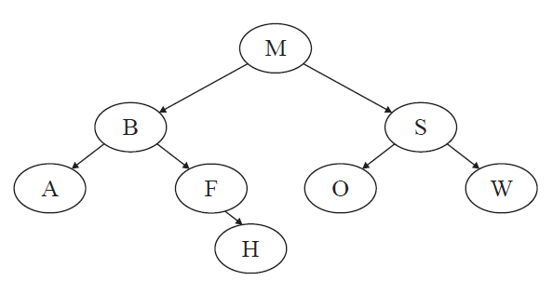Consider the following binary search tree.
2. State the order in which data will be listed using preorder traversal. [1]

*Award* ***[1 mark]*** *for correctly stating the solution.*

M B A F H S O W;

1. State the number of leaf nodes in the tree. [1]

*Award* ***[1 mark]*** *for stating the correct number of leaf nodes.*

4;

1. Construct the tree after adding the node L. [1]

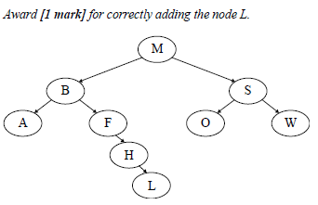

**Section B**

1. The temperature (in °C) of a lake was recorded every hour, every day, for one week. As each reading was taken, it was added sequentially to the collection TEMPERATURES, which is stored permanently.

At the end of the week this data was read into a two-dimensional array named TEMPWEEK as shown below.

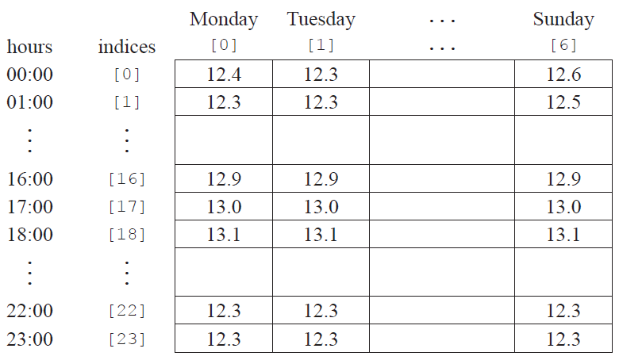

1. Construct the algorithm that will read the data from the collection into the array. You can use the   
   collection functions TEMPERATURES.getNext() and TEMPERATURES.isEmpty(). [5]

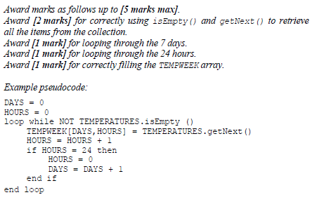

1. Using the array TEMPWEEK, construct an algorithm to determine and output the minimum   
   temperature for the week. [4]

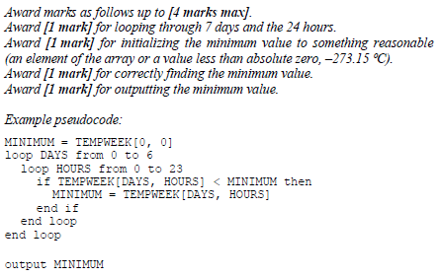

1. If the temperature is less than 12.0°C then the day, time and temperature are also placed in  
   a separate data structure.
2. Describe a dynamic data structure that might be used to hold this data. You may use a   
   labelled diagram. [3]

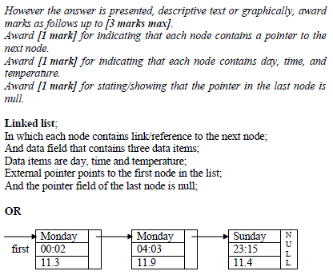

1. Using this dynamic structure suggest how the number of days when the temperature of   
   the lake was below 12.0°C can be found. [3]

*Award* ***[1 mark]*** *for each step identified up to* ***[3 marks max]****.*

Set counter to zero (0);

Start from the beginning of the list;

While the end of list is not reached;

Increase counter by 1;

Follow the pointers/links;

1. A business has decided to replace their current computer system with a new computer system.
2. Identify three examples of how employees, as users of the computer system,   
   may participate in the development of the new system. [3]

*Award* ***[1 mark]*** *for each example up to* ***[3 marks max]****.*

They may explain how the current system works;

They may explain how it could be improved;

They may provide requirements/objectives;

They may be involved in approving the proposed solution;

They may evaluate one or more prototypes;

They may test the system to ensure that it works as expected;

They will be attending the training lessons to learn how to use the new system;

They will be using the system;

1. One method of conversion from the old computer system to the new computer   
   system is parallel running.
2. Define the term parallel running. [1]

The old system continues alongside the new system for a certain period of time;

1. Identify **one** other method of conversion. [1]

*Award* ***[1 mark]*** *for one method of conversion (other than parallel running) identified.*

Direct changeover;

Phased conversion;

Pilot conversion;

1. Compare parallel running with the method of conversion identified in part (ii). [4]

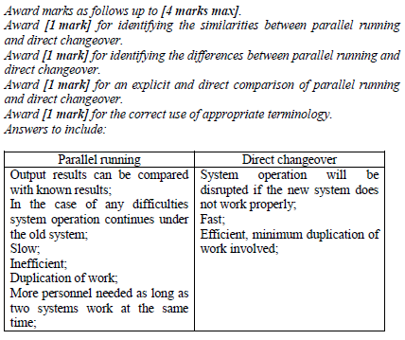

1. The data from the old computer system needs to be transferred onto the new computer system.   
   Discuss **two** problems that may arise as a result of this data migration. [6]

*Award marks as follows up to* ***[6 marks max]****.*

*Award* ***[1 mark]*** *for each distinct problem identified, up to* ***[2 marks max]****.*

*Award* ***[1 mark]*** *for a description of each identified problem, up to* ***[2 marks max]****.*

*Award* ***[1 mark]*** *for an elaboration of the identified problems.*

*Award* ***[1 mark]*** *for correct terminology used throughout.*

*Answers may include:*

Incompatible formats of data: The new system may store data in a format different from that used in the old system. This might be a simple matter of translation, such as converting integers to decimals. It could also be very difficult if the new system stores more detailed data than the old system, such as the date and time of each transaction while the old system stored only the date.

Data lost in migration: Data might be lost due to errors in the translation process or because perfect translations simply aren’t possible, *e.g.* if the old system stored ratings on a scale of 1–5 while the new system stored only 1–3.

The systems may be unavailable during the migration process; one way to avoid having two systems with incompatible data is to shutdown the business, perform the migration, and then restart with the new system. If the migration takes a long time however, shutting down the business for that time may be undesirable.

New data may continue coming in during the migration process; if the business is not shutdown during the migration process, transactions will either have to be performed on the new system without the old data being available or they will have to be performed on the old system which will add to the data needing to be migrated.

1. 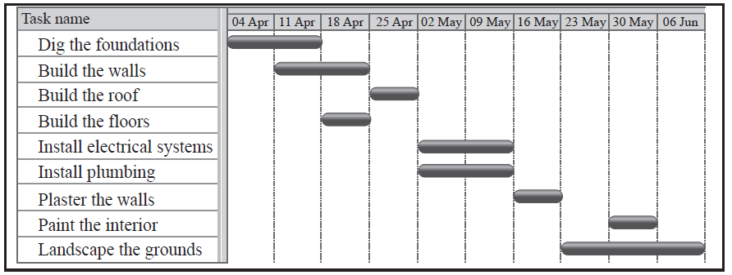Señor Rodriguez is having a new house built and will require local tradesmen to complete  
   a number of tasks.  
     
   The Gantt chart below shows the tasks involved in the building of the house.
2. Define the term concurrent processing. [1]

*Award* ***[1 mark]*** *for a definition that covers the basis of the term.*

Concurrent processing means to do more than one activity at the same time;

1. Identify **two** tasks that are carried out concurrently. [1]

*Award* ***[1 mark]*** *for a pair of tasks correctly identified.*

Install plumbing and install electrical systems;

1. Identify **two** tasks that are carried out sequentially. [1]

*Award* ***[1 mark]*** *for a pair of tasks correctly identified.*

Any two tasks in which one cannot begin before the other is completed:

Digging the foundation and building the floors;

Building the walls and building the roof;

Building the roof and plastering the walls;

1. Describe how the idea of abstraction applies to one of the tasks. [2]

*Award* ***[1 mark]*** *for identifying a task as composed of subtasks.*

*Award* ***[1 mark]*** *for describing some reasonable set of subtasks.*

Describe one of the tasks as being composed of subtasks:

Build the floors: Install the beams, install the joists, install the subfloor, install the finish floor.

Paint the walls: Mask off things not to paint, cover floors, select paint colours, paint trim, paint walls, paint ceilings.

Landscaping: Plan the plantings, get the plants, dig holes, plant things, seed the lawn, install lighting.

1. Explain **one** advantage and **one** disadvantage of carrying out a number  
   of tasks concurrently. [4]

*Award* ***[1 mark] each*** *for the identification of an advantage and a disadvantage.*

*Award up to* ***[2 marks]*** *for explaining the advantage and disadvantage.*

*Advantages:*

Building could be finished faster; By doing some tasks concurrently, the overall time needed to complete the building will be reduced. Since construction workers are paid by the hour, getting the building done sooner will reduce the cost of the building.

*Disadvantages:*

Workers on concurrent tasks may get in each other’s way; If the plumbers and the electricians are both working at the same time and both need to get at the same place at the same time, one will have to wait. Thus, it may take longer to do the electrical work while the plumbing is being done than it would take to do it alone.

Harder to supervise; The supervisor needs to look at the work being done and make sure that its being done correctly and explain what needs to be done, *etc*. If there are two (or more) sets of workers the supervisor will have to work harder to watch both of them at the same time.

Amalia Rodriguez, his daughter, is a student and is completing her homework.   
 This requires her to view web pages, edit a document, and print out draft copies.

However, she is also surfing the web, keeping up to date on her social networking  
 site as well as downloading apps and music from a P2P site.

1. For one of the application programs which she uses to perform these activities,  
   outline one task that is carried out by the application program itself. [2]

*Award* ***[1 mark]*** *for identifying an application.*

*Award an additional* ***[1 mark]*** *for outlining a task carried out by the application.*

The word processor: counting the number of words in the document.

The browser: Interpreting the HTML to figure out what to display.

The downloading program: Calculating the amount of time remaining to complete the download.

Within the application the graphical user interface (GUI) elements are reliant on the   
 operating system.

1. Identify two GUI components that are common to all of the above and are carried  
   out by the operating system. [2]

*Award* ***[1 mark]*** *for each GUI component identified up to* ***[2 marks max]****.*

Toolbars;

Menus;

Dialogue boxes;

Buttons;

Check boxes;

Text-entry fields;

1. Outline how the use of abstract GUI components simplifies application programming. [2]

*Award* ***[1 mark]*** *for identifying one way in which the use of abstract GUI components simplifies application programming.*

*Award an additional* ***[1 mark]*** *for a description of the idea identified above or the identification of a second idea up to* ***[2 marks max]****.*

Application developers do not have to implement basic GUI components.

All applications use the same basic GUI elements resulting in a better user experience.

The operating system coordinates GUI elements for all applications reducing the need for developers to do so.

Application code is much smaller since all the GUI-related code is in a standard library.

1. The operating system in the latest mobile phones allows the user to open more than   
   one application at the same time.
2. State **three** possible applications that might be open at the same time. [1]

*Award* ***[1 mark]*** *for three or more acceptable possible applications stated.*

Internet browser

Phone application (making a call)

Camera application (taking a picture)

MP3 player

E-mail reader

1. Explain the role of the operating system in the management of these applications. [4]

*Award marks as follows up to* ***[4 marks max]****.*

*Award* ***[2 marks]*** *for a basic description of the operating system in the management of applications.*

*Award* ***[1 mark]*** *for elaborating on the description.*

*Award* ***[1 mark]*** *for an explanation that is clear, detailed and balanced.*

*Answers may include:*

Memory management: The OS allocates a certain portion of the memory for each application. The amount of memory needed by each application may change so the OS will need to be able to allocate more memory to an application as needed and to recover memory when the application no longer needs it.

Allocation of processing time for each application: This could involve time-slicing in which each application is given a certain amount of processor time before control is switched to the next application. Alternatively, the OS could use an event-driven model in which control of the processor is passed to the appropriate application as events such as an incoming call, a button press, or an interrupt occur.

Coordination of interfaces: The OS determines which application should be notified if a button is pressed and updates the display based on requests received from each of the applications.

The intended uses of a mobile phone influence its design with regard to system resources.

1. With reference to two specific resources, outline how the design of these resources  
   for a mobile phone would differ from those of a standard PC. [4]

*Award* ***[1 mark each]*** *for identifying each valid system resource up to a maximum of* ***[2 marks]****.*

*Award an additional* ***[1 mark each]*** *for describing how the design of each of the identified resources differ between the mobile phone and PC platforms up to a maximum of* ***[2 marks]****.*

*Answers may include:*

**Memory**: The small size of the mobile phone restricts the amount of memory that can be included to less than what can be included in a PC. More importantly, the mobile must use much less power than a PC and this further restricts the amount of memory that can be included and also makes some designers choose slower memory that consumes less power.

**Display Screen**: The small size of the mobile restricts the size of the screen to something much less than a PC. To compensate, the screen may need to have a much higher resolution. Also, the mobile screen must be readable in direct sunlight, which most PC displays are not.

**Input devices**: The PC usually uses a full-size keyboard. The mobile must generally use a much smaller keyboard which results either in a greatly reduced number of keys or in very tiny keys such as on a Blackberry. The PC also usually has a pointing device like a mouse which itself is already larger than many mobile phones. Instead, mobile phones may use a touch sensitive screen.

A mobile phone manufacturer is considering adding a graphics card to one of   
 its models.

1. Discuss the possible consequences of going ahead with this modification. [6]

*Award marks as follows up to* ***[6 marks max]****.*

*Award* ***[1 mark]*** *for each consequence identified, up to* ***[2 marks max]****.*

*Award* ***[2 marks]*** *for a deeper description of the consequences, demonstrating some knowledge and understanding.*

*Award* ***[2 marks]*** *for a clear discussion of the consequences in terms of size, weight, power, usability, and user appeal, showing detailed knowledge and understanding.*

*Answers may include:*

Will speed the display of complex graphics, will make animations and movies look great.

Video card uses a lot of power, will reduce battery life and increase heat.

Video card occupies space, will make phone larger and heavier.

1. A company uses computer controlled equipment to monitor and control a heating system. The user controls the system via an on/off switch and two dials that are used to set the maximum and minimum temperatures desired.

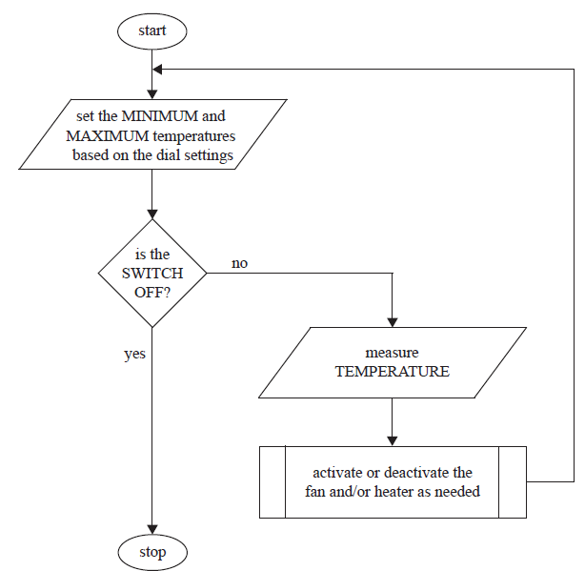The following flowchart represents the algorithm used to control temperature.

The temperature is constantly measured and the process of making the decision on   
which action to take is as follows.

If it is too cold (temperature is less than the minimum) then the heater should be  
switched on. If it is too hot (temperature is greater than the maximum) then the   
fan should be switched on. If temperature is within the given range (temperature  
greater than the minimum and less than the maximum) then both the fan and heater  
should be switched off.

1. Identify **one** situation in which the system should respond to
2. input from a user; [1]

*Award* ***[1 mark]*** *for identifying a user input.*

Min and max temperature;

System on or off;

1. temperature. [1]

*Award* ***[1 mark]*** *for identifying one of the situations.*

When the temperature is above the max;

When the temperature is below the min;

When the temperature is between the max and the min;

1. State three hardware devices that are needed to capture the input data and   
   produce the system outputs. [3]

*Award* ***[1 mark]*** *for each hardware device identified up to* ***[3 marks max]****.*

Sensors;

Transducers;

AD converters;

Actuators;

Heater;

Fan;

1. Construct pseudocode for the algorithm outlined on the previous page. [4]

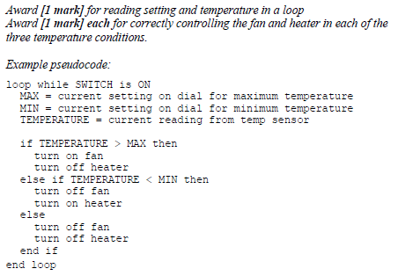

1. The company wants to use its heating system to control the temperature of ten   
   different places at the same time. All ten places will have the same maximum and  
   minimum temperatures and each will have its own heater, fan, and temperature  
   sensor. Evaluate the decision of having all ten temperature sensors, fans, and heaters  
   connected to a single control computer instead of having ten separate heating systems. [6]

*Award marks as follows up to* ***[6 marks max]****.*

*Award* ***[1 mark]*** *for each advantage identified, up to* ***[2 marks max]****.*

*Award* ***[1 mark]*** *for each disadvantage identified, up to* ***[2 marks max]****.*

*Award* ***[1 mark]*** *for a contrast of the identified advantages and disadvantages.*

*Award* ***[1 mark]*** *if the contrast is clear, and explains the relevance of the advantages and disadvantages.*

*Possible advantages include:*

Only need a single set of max/min dials and only one on/off switch.

There is no way for the locations to accidently have different settings.

All ten locations can be controlled from a single place so you don’t have to run around to each one.

All the temperature data is available in one place, which may make recording and analyzing it easier.

*Possible disadvantages include:*

May need a lot of wires to connect all the locations to the control computer.

If the control computer breaks, all the locations suffer.

The software will have to be changed.